DATABASE PROJECT (FINAL)

12. (A) EMPLOYEE_INFO: -

1.

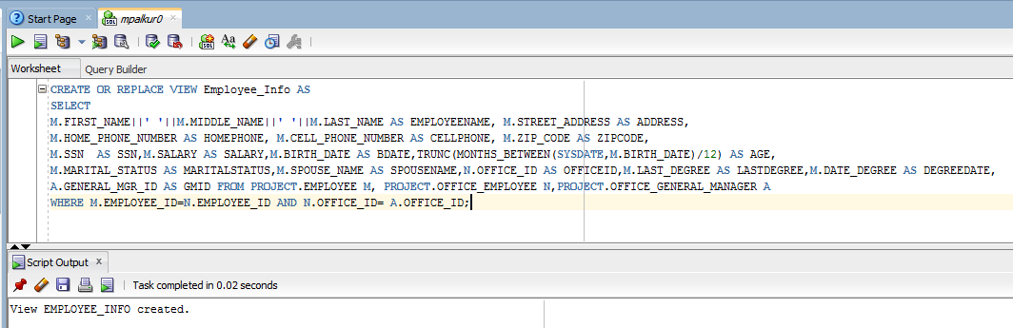

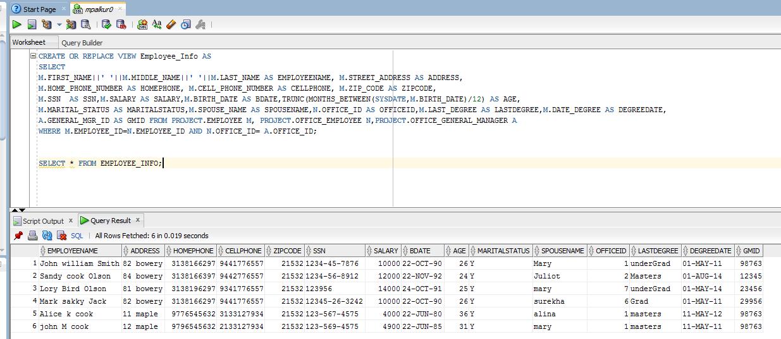

12. (B) EMPLOYEE_SALARY: -

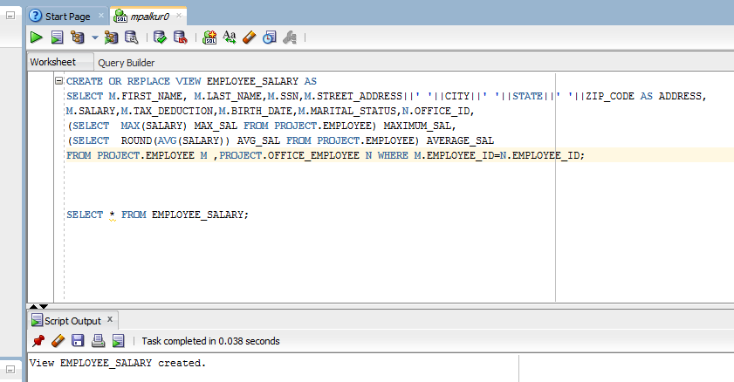

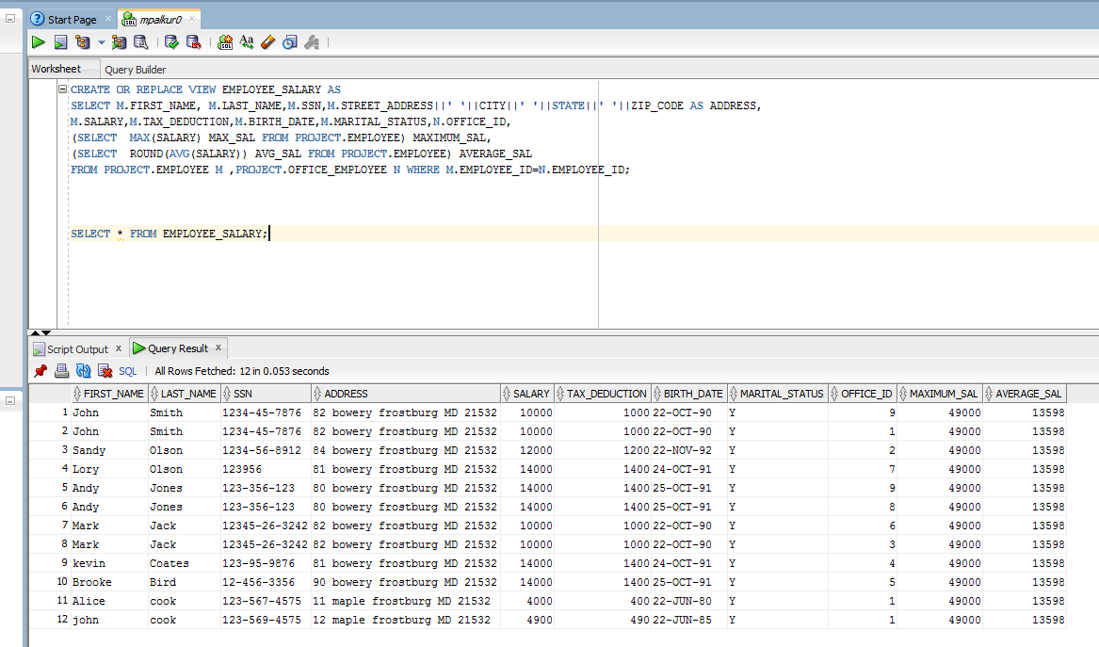

12. (C) BRANCH_INFO: -

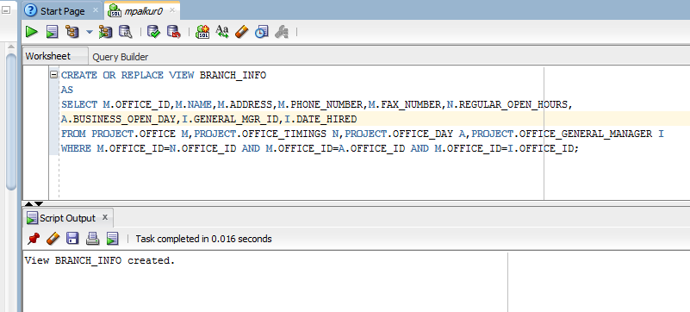

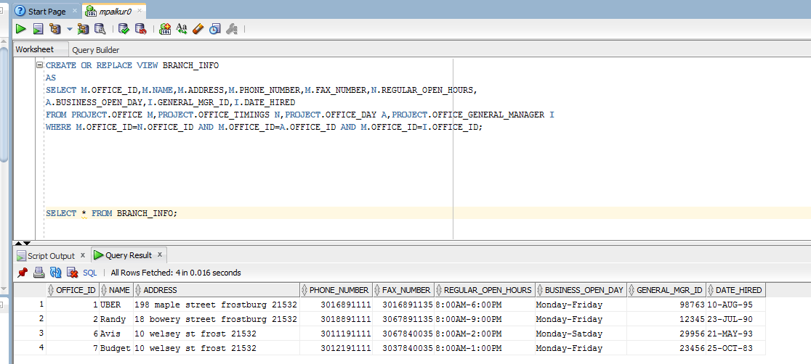

12. (D) VALUED_CUSTOMERS: -

CREATE OR REPLACE VIEW VALUED_CUSTOMERS

AS

SELECT C_NAME,C_AGE,CELL_NUMBER,C_ADDRESS,ZIPCODE,C_EMAIL,C_LICENSE_NUMBER,LICENSE_ISSUED_STATE,NO_OF_TIMES_CAR_RENTED FROM

(SELECT CUSTOMER_ID,FIRST_NAME||' '||LAST_NAME AS C_NAME,(TO_CHAR(SYSDATE,'yyyy')-TO_CHAR(BIRTH_DATE,'yyyy')) AS C_AGE,

CELL_PHONE AS CELL_NUMBER,STREET_ADDRESS||' '||CITY||' '||STATE AS C_ADDRESS,ZIP_CODE AS ZIPCODE,EMAIL AS C_EMAIL,

LICENSE_NUMBER AS C_LICENSE_NUMBER,LICENSE_ISSUED_STATE

FROM PROJECT.CUSTOMER)CAR_ST_REG

JOIN

(SELECT CUSTOMER_ID,COUNT(*) NO_OF_TIMES_CAR_RENTED FROM PROJECT.CAR_CUSTOMER_RENT GROUP BY CUSTOMER_ID)CAR_CUS_RENT

ON CAR_ST_REG.CUSTOMER_ID=CAR_CUS_RENT.CUSTOMER_ID;

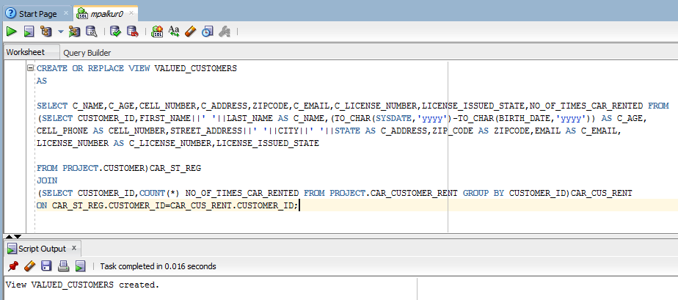

SELECT * FROM VALUED_CUSTOMERS;

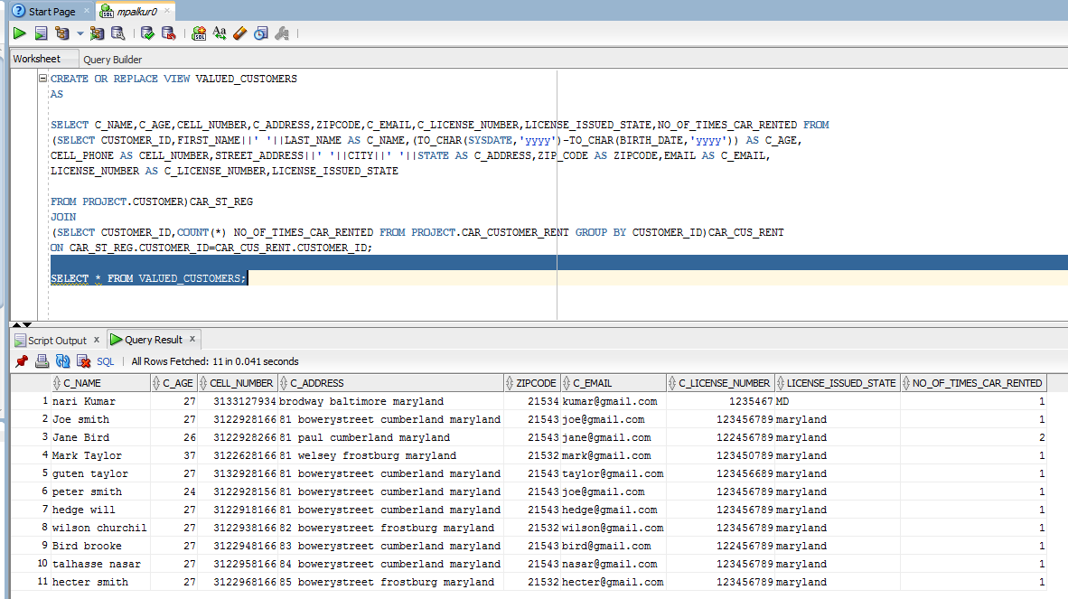

12. (E) LIST_OF_CARS: -

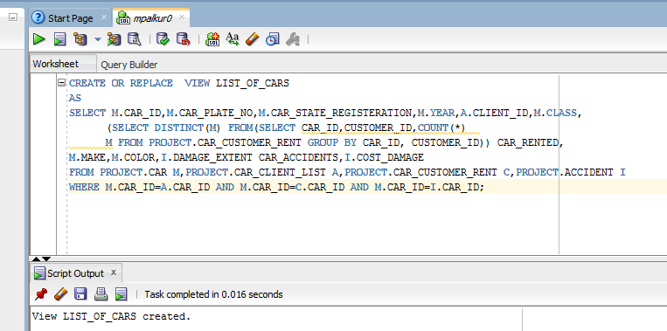

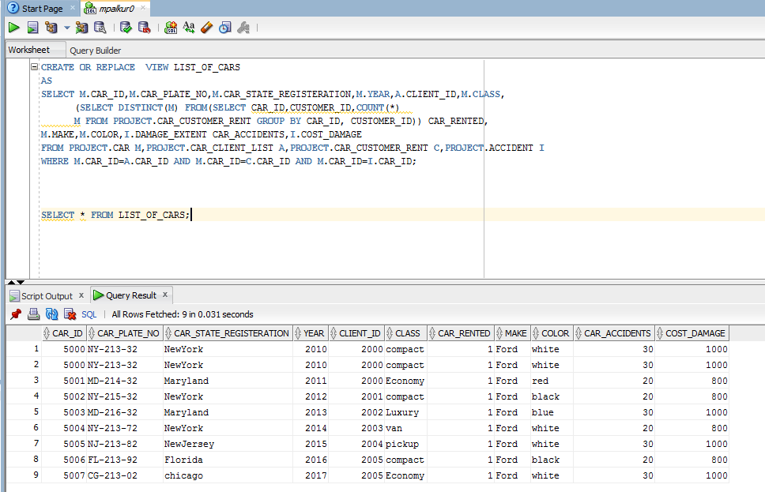

12. (F) LIST_OF_TRANSACTIONS: -

CREATE OR REPLACE VIEW LIST_OF_TRANSACTIONS

AS

SELECT

(SELECT (END_DATE - START_DATE) FROM PROJECT.CAR_CLIENT_LIST) DAY_CAR_USED ,

M.PAYMENT_AMOUNT,A.DAILY_PRICE,

(SELECT (DAILY_PRICE*7*WEEKLY_DISCOUNT/100) M FROM PROJECT.CAR) WEEKLY_PRICE,

(SELECT (DAILY_PRICE*30*MONTHLY_DISCOUNT/100) M FROM PROJECT.CAR) MONTHLY_PRICE,

M.LOCATION_RETURN,M.TOTAL_MILEAGE,N.EMPLOYEE_ID

FROM PROJECT.CAR_CUSTOMER_RENT M,PROJECT.CAR A,PROJECT.EMPLOYEE_CAR_LIST N

WHERE M.CAR_ID=A.CAR_ID AND M.CAR_ID=N.CAR_ID;

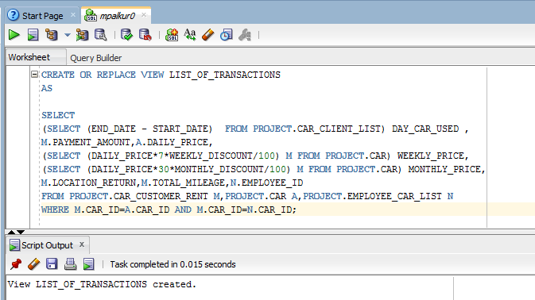

SELECT * FROM LIST_OF_TRANSACTIONS;

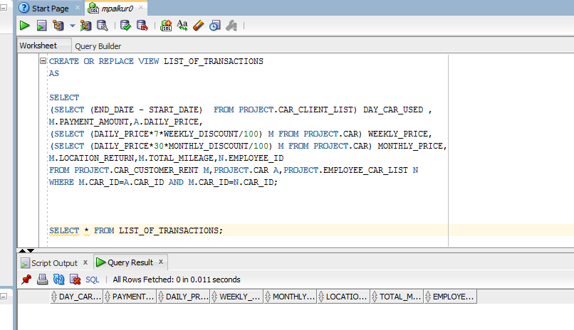

12. (G) STATISTICS_BY_BRANCH: -

CREATE OR REPLACE VIEW STATISTICS_BY_BRANCH_YEAR AS

SELECT R.OFFICE_ID,M.FIRST_NAME||' '||M.MIDDLE_INITIAL||' '||M.LAST_NAME CLIENT_NAME, I.FIRST_NAME||' '||I.MIDDLE_INITIAL||' '||I.LAST_NAME CAR_RENTER_NAME,EXTRACT(YEAR FROM H.DATE_OF_RENT) YEAR,COUNT(C.CLIENT_ID)CLIENT_CAR_LIST,SUM(H.PAYMENT_AMOUNT) MONEY_RECEIVED

FROM OFFICE R,EMPLOYEE_CUSTOMER B,EMPLOYEE_CLIENT_MANAGE C,EMPLOYEE D,CUSTOMER I,CLIENT M,OFFICE_EMPLOYEE G,CAR_CUSTOMER_RENT H

WHERE B.EMPLOYEE_ID=C.EMPLOYEE_ID AND C.EMPLOYEE_ID=D.EMPLOYEE_ID AND B.CUSTOMER_ID=I.CUSTOMER_ID AND C.CLIENT_ID=M.CLIENT_ID AND R.OFFICE_ID=G.OFFICE_ID AND H.CUSTOMER_ID=I.CUSTOMER_ID

GROUP BY R.OFFICE_ID,M.FIRST_NAME,M.MIDDLE_INITIAL,M.LAST_NAME, I.FIRST_NAME,I.MIDDLE_INITIAL,I.LAST_NAME, H.DATE_OF_RENT,C.CLIENT_ID, H.PAYMENT_AMOUNT

ORDER BY R.OFFICE_ID,EXTRACT(YEAR FROM H.DATE_OF_RENT);

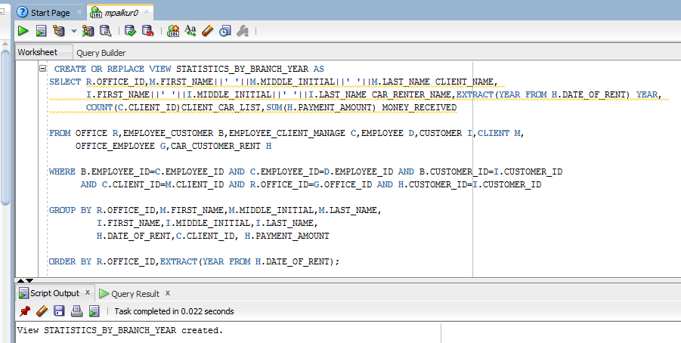

SELECT * FROM STATISTICS_BY_BRANCH_YEAR;

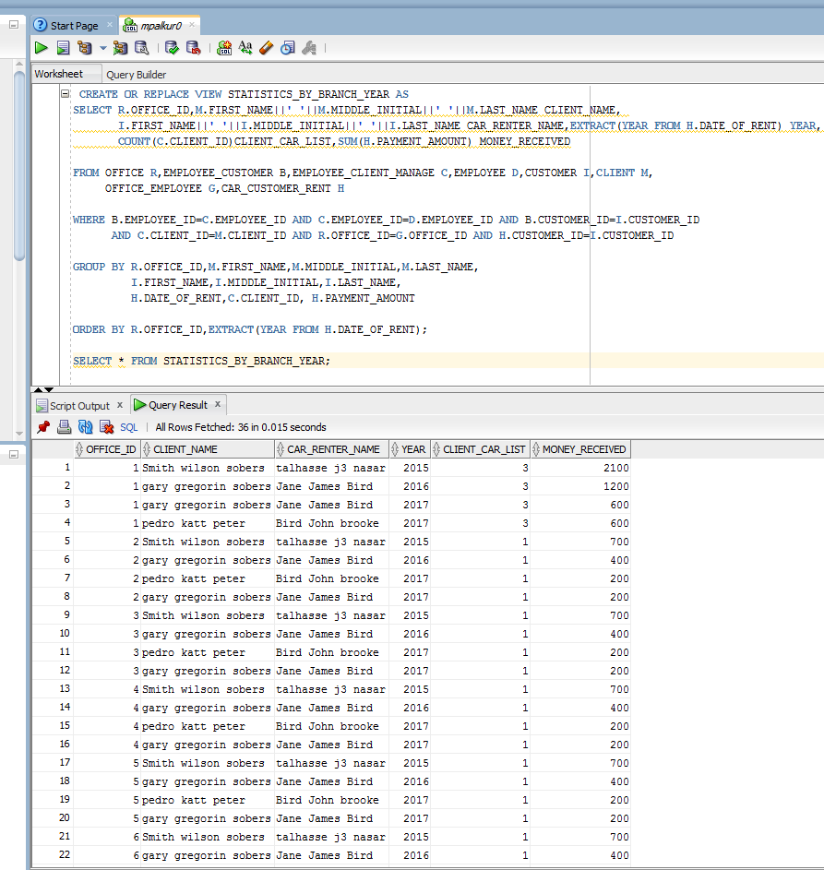

12. (H) LAST_EMPLOYEE_BRANCH : -

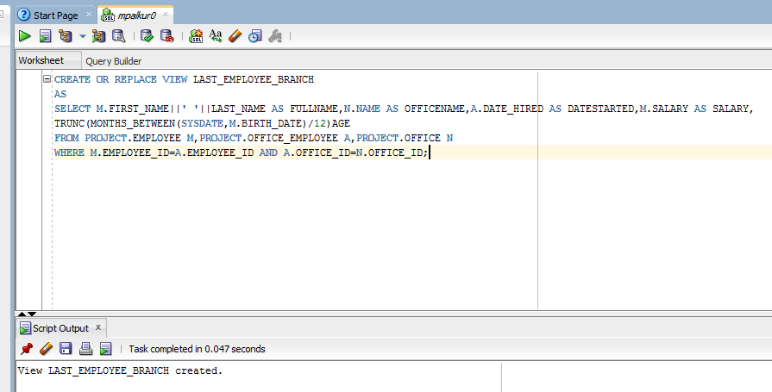

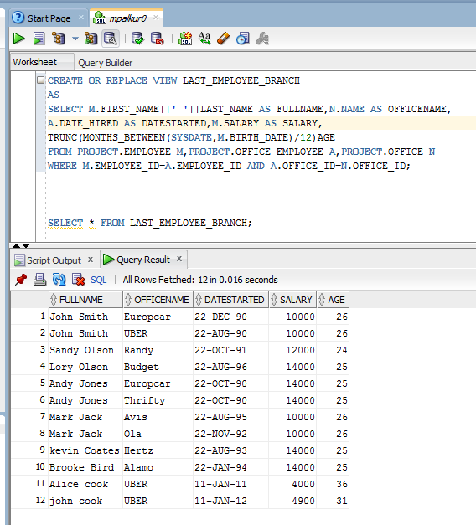

12. (I) MANAGERS: -

CREATE OR REPLACE FORCE VIEW MANAGERS AS

SELECT M.FIRST_NAME || ' ' || M.MIDDLE_NAME || ' ' || M.LAST_NAME AS MANAGER_NAME, N.DATE_HIRED,

(SELECT COUNT (*) FROM EMPLOYEE R, OFFICE_EMPLOYEE NAM

WHERE NAM.EMPLOYEE_ID = R.EMPLOYEE_ID AND NAM.OFFICE_ID = N.OFFICE_ID) AS NO_OF_EMPLOYEE

FROM OFFICE_GENERAL_MANAGER N, EMPLOYEE M

WHERE M.EMPLOYEE_ID = N.GENERAL_MGR_ID;

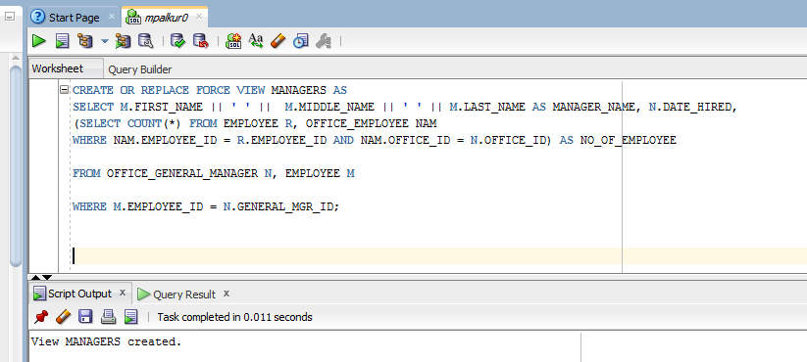

SELECT * FROM MANAGERS;

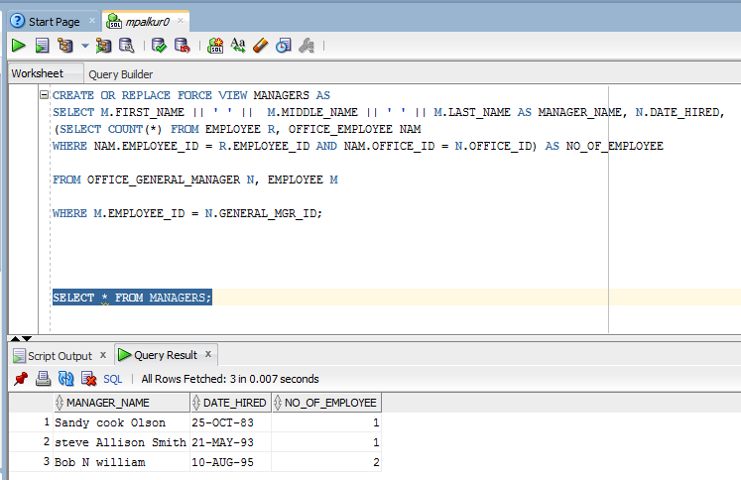

**12. (J)**

CREATE OR REPLACE VIEW CAR_RENT_DETAILS

AS

SELECT M.DATE_OF_RENT AS RENTED_DATE, M.PAYMENT_AMOUNT AS AMOUNT_PAID, M.PAYMENT_TYPE, A.START_DATE, A.END_DATE

FROM PROJECT.CAR_CUSTOMER_RENT M, PROJECT.CAR_CLIENT_LIST A

WHERE M.CAR_ID=A.CAR_ID;

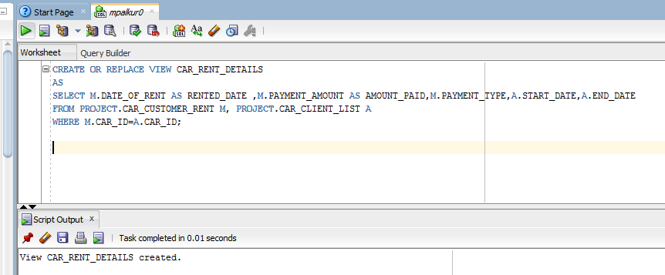

SELECT * FROM CAR_RENT_DETAILS;

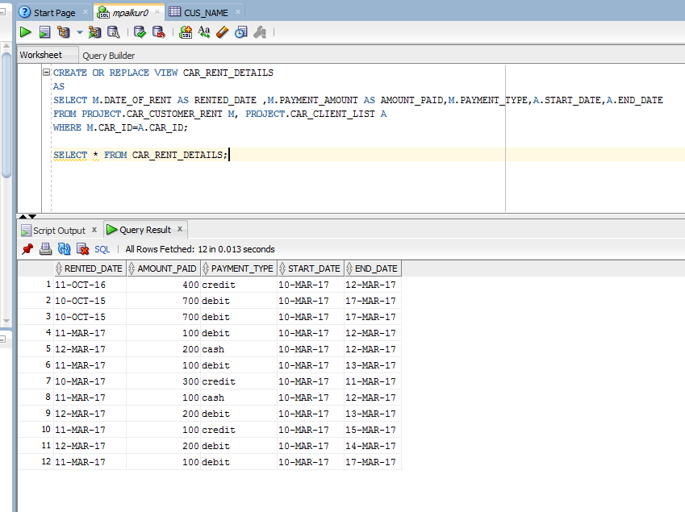

**12. (K**)

CREATE OR REPLACE VIEW CAR_PRICE

AS

SELECT MAKE AS CAR_NAME, DAILY_PRICE, MILES_INCLUDED

FROM PROJECT.CAR

WHERE DAILY_PRICE > (SELECT AVG (DAILY_PRICE) FROM PROJECT.CAR);

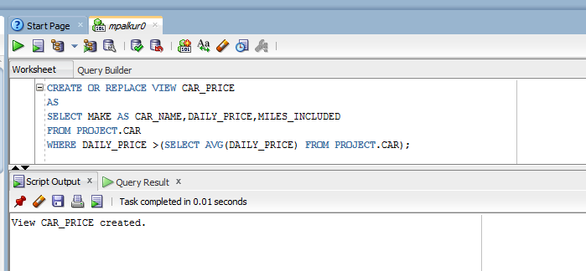

SELECT * FROM CAR_PRICE;

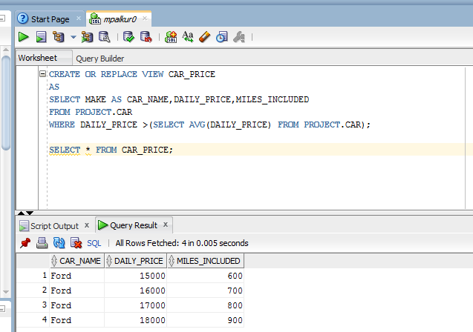

***13. INDEX: -***

A.

CREATE TABLE CUS_NAME AS ( SELECT * FROM PROJECT.CUSTOMER);

CREATE INDEX CUS1

ON CUS_NAME (FIRST_NAME||' '||LAST_NAME);

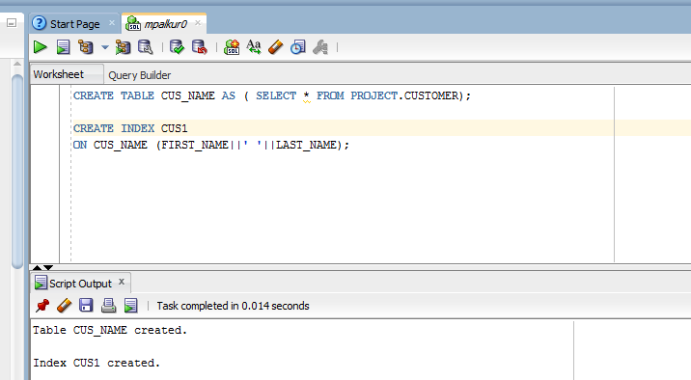

b. BIRTHDATE: -

CREATE TABLE CUS_NAME AS ( SELECT * FROM PROJECT.CUSTOMER);

CREATE INDEX B_DATE

ON CUS_NAME (BIRTH_DATE);

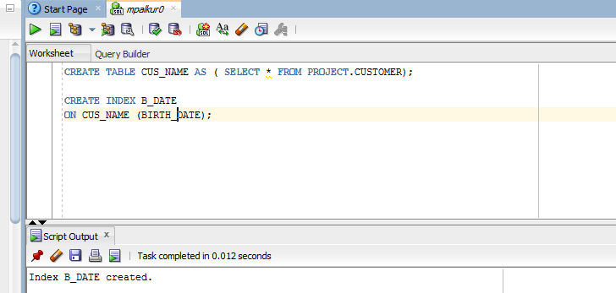

***14. SEQUENCES: -***

**A.**

CREATE SEQUENCE ID_GENERATOR

MINVALUE 0

MAXVALUE 500000

START WITH 1000

INCREMENT BY 4

CACHE 40;

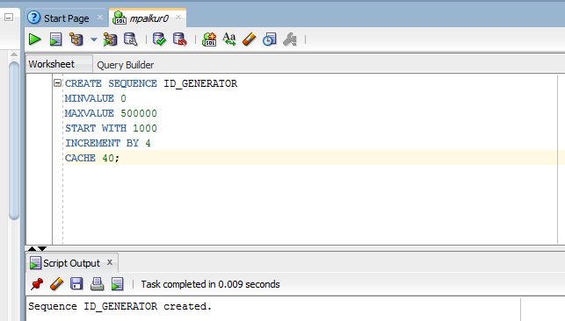

**B.**

CREATE SEQUENCE TRANSACTION_ID

MINVALUE 0

MAXVALUE 5000000

START WITH 10000

INCREMENT BY 2

CACHE 50;

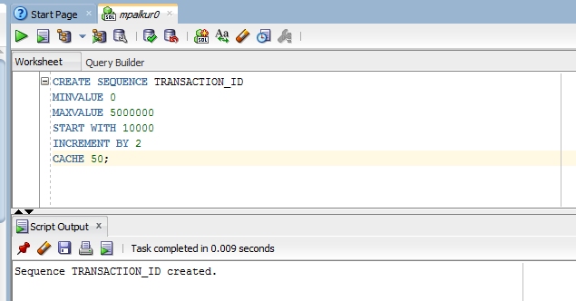

**C.**

CREATE SEQUENCE TRACK_NUMBER

MINVALUE 0

MAXVALUE 57000000

START WITH 0

INCREMENT BY 1

CACHE 50;

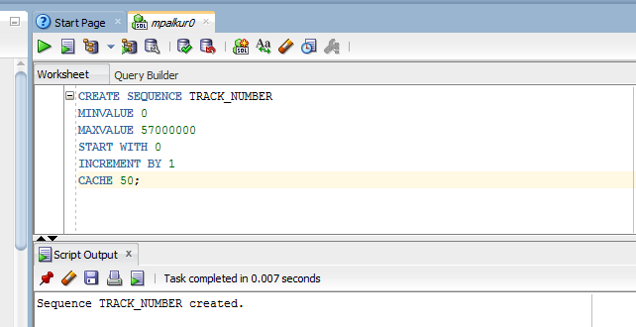

**D.**

CREATE TABLE INQUIRIES (REQ_NUMBER NUMBER (10), REQ_DATE DATE, TYPE_OF_REQUEST VARCHAR2 (40), NAME_OF_PERSON VARCHAR2 (20), EMAIL_ID VARCHAR2 (40));

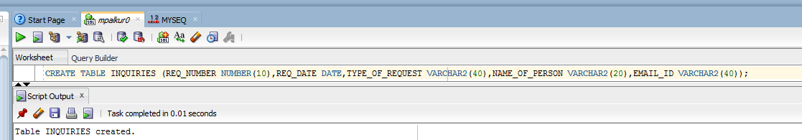

INSERT INTO INQUIRIES VALUES (TRACK_NUMBER.NEXTVAL, TO_DATE ('2017-01-15','YYYY-MM-DD'),'PULKA','THEMALA','THEMALA@YAHOO.COM');

INSERT INTO INQUIRIES VALUES (TRACK_NUMBER.NEXTVAL, TO_DATE ('2017-02-10','YYYY-MM-DD'),'HULKA','SELVA','SELVA@YAHOO.COM');

INSERT INTO INQUIRIES VALUES (TRACK_NUMBER.NEXTVAL, TO_DATE ('2017-03-15','YYYY-MM-DD'),'DAFFA','RAJ','RAJ@YAHOO.COM');

INSERT INTO INQUIRIES VALUES (TRACK_NUMBER.NEXTVAL, TO_DATE ('2017-04-20','YYYY-MM-DD'),'JAFFA','MANOJ','MANOJ@YAHOO.COM');

INSERT INTO INQUIRIES VALUES (TRACK_NUMBER.NEXTVAL, TO_DATE ('2017-05-25','YYYY-MM-DD'),'MAFFA','KUMAR','KUMAR@YAHOO.COM');

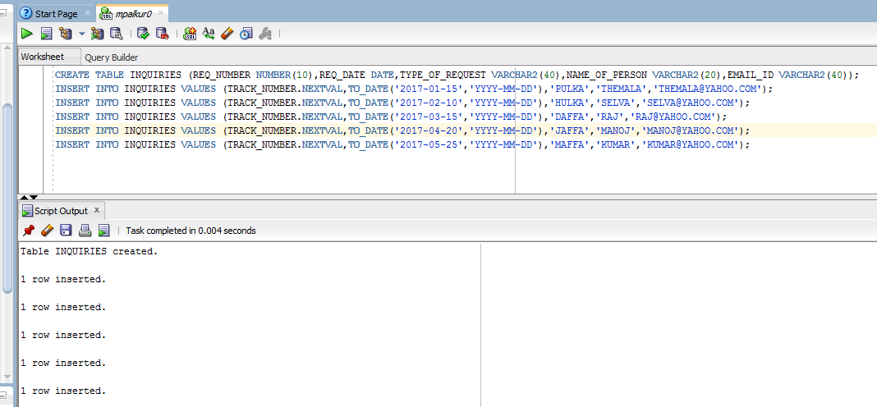

SELECT * FROM INQUIRIES;

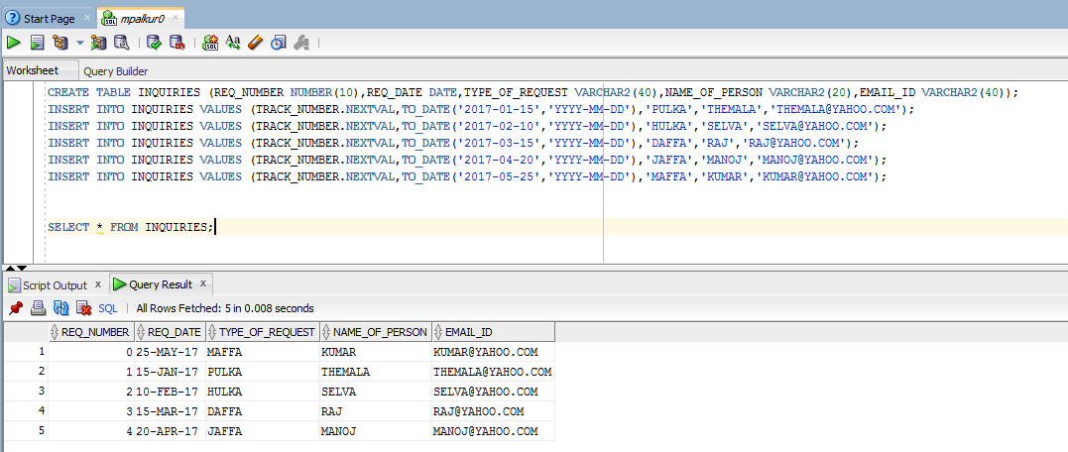

***15. SUBPROGRAMS & PACKAGES: -***

A. EMPINSERT_PKG: -

CREATE OR REPLACE PACKAGE EMPINSERT_PKG AS

PROCEDURE INSERT_DATA

(EMPLOYEE_ID EMPLOYEE.EMPLOYEE_ID%TYPE,FIRST_NAME EMPLOYEE.FIRST_NAME%TYPE, MIDDLE_NAME EMPLOYEE.MIDDLE_NAME%TYPE,LAST_NAME EMPLOYEE.LAST_NAME%TYPE,GENDER EMPLOYEE.GENDER%TYPE,STREET_ADDRESS EMPLOYEE.STREET_ADDRESS%TYPE, CITYEMPLOYEE.CITY%TYPE,STATE EMPLOYEE.STATE%TYPE,ZIP_CODE EMPLOYEE.ZIP_CODE%TYPE,SSN EMPLOYEE.SSN%TYPE, SALARY EMPLOYEE.SALARY%TYPE,TAX_REDUCTIONEMPLOYEE.TAX_DEDUCTION%TYPE,BIRTH_DATE EMPLOYEE.BIRTH_DATE%TYPE,MARITAL_STATUS EMPLOYEE.MARITAL_STATUS%TYPE,SPOUSE_NAME EMPLOYEE.SPOUSE_NAME%TYPE,LAST_DEGREE EMPLOYEE.LAST_DEGREE%TYPE,

DATE_DEGREE EMPLOYEE.DATE_DEGREE%TYPE,NO_OF_DEPENDENTS EMPLOYEE.NO_OF_DEPENDENTS%TYPE,HOME_PHONE_NUM EMPLOYEE.HOME_PHONE_NUMBER%TYPE,CELL_PHONE_NUM EMPLOYEE.CELL_PHONE_NUMBER%TYPE);

PROCEDURE MARITAL_STATUS_UPDATE(A_EMPLOYEE IN EMPLOYEE.EMPLOYEE_ID%TYPE,A_MARITAL_STATUS EMPLOYEE.MARITAL_STATUS%TYPE);

PROCEDURE LAST_DEGREE_UPDATE(A_EMPLOYEE EMPLOYEE.EMPLOYEE_ID%TYPE,A_LAST_DEGREE EMPLOYEE.LAST_DEGREE%TYPE);

PROCEDURE CERTIFICATE_UPDATE(A_EMPLOYEE EMPLOYEE_CERTIFICATES.EMPLOYEE_ID%TYPE,A_CERTIFICATE EMPLOYEE_CERTIFICATES.LIST_OF_CERTIFICATES%TYPE);

PROCEDURE MANAGER_UPDATE(MANAGER_ID OFFICE_GENERAL_MANAGER.GENERAL_MGR_ID%TYPE,A_EMPLOYEE EMPLOYEE.EMPLOYEE_ID%TYPE);

END EMPINSERT_PKG;

/

SET SERVEROUTPUT ON;

CREATE OR REPLACE PACKAGE BODY EMPINSERT_PKG AS

PROCEDURE INSERT_DATA

(EMPLOYEE_ID EMPLOYEE.EMPLOYEE_ID%TYPE,FIRST_NAME EMPLOYEE.FIRST_NAME%TYPE,MIDDLE_NAME EMPLOYEE.MIDDLE_NAME%TYPE,LAST_NAME EMPLOYEE.LAST_NAME%TYPE,GENDER EMPLOYEE.GENDER%TYPE,STREET_ADDRESS EMPLOYEE.STREET_ADDRESS%TYPE,CITY EMPLOYEE.CITY%TYPE,STATE EMPLOYEE.STATE%TYPE,ZIP_CODE EMPLOYEE.ZIP_CODE%TYPE,SSN EMPLOYEE.SSN%TYPE,SALARY EMPLOYEE.SALARY%TYPE,TAX_REDUCTION EMPLOYEE.TAX_DEDUCTION%TYPE,BIRTH_DATE EMPLOYEE.BIRTH_DATE%TYPE,MARITAL_STATUS EMPLOYEE.MARITAL_STATUS%TYPE,SPOUSE_NAME EMPLOYEE.SPOUSE_NAME%TYPE,LAST_DEGREE EMPLOYEE.LAST_DEGREE%TYPE,DATE_DEGREE EMPLOYEE.DATE_DEGREE%TYPE,NO_OF_DEPENDENTS EMPLOYEE.NO_OF_DEPENDENTS%TYPE,HOME_PHONE_NUM EMPLOYEE.HOME_PHONE_NUMBER%TYPE,

CELL_PHONE_NUM EMPLOYEE.CELL_PHONE_NUMBER%TYPE) AS

BEGIN

INSERT INTO EMPLOYEE (EMPLOYEE_ID,FIRST_NAME,MIDDLE_NAME,LAST_NAME,GENDER,STREET_ADDRESS,CITY,STATE,ZIP_CODE,SSN,SALARY,TAX_DEDUCTION,BIRTH_DATE,MARITAL_STATUS,

SPOUSE_NAME,LAST_DEGREE,DATE_DEGREE,NO_OF_DEPENDENTS,HOME_PHONE_NUMBER,CELL_PHONE_NUMBER)

VALUES(EMPLOYEE_ID,FIRST_NAME,MIDDLE_NAME,LAST_NAME,GENDER,STREET_ADDRESS,CITY,STATE,ZIP_CODE,SSN,SALARY,TAX_REDUCTION,BIRTH_DATE,MARITAL_STATUS,

SPOUSE_NAME,LAST_DEGREE,DATE_DEGREE,NO_OF_DEPENDENTS,HOME_PHONE_NUM,CELL_PHONE_NUM);

DBMS_OUTPUT.PUT_LINE('EMPLOYEE TABLE UPDATED');

END;

PROCEDURE MARITAL_STATUS_UPDATE(A_EMPLOYEE IN EMPLOYEE.EMPLOYEE_ID%TYPE,A_MARITAL_STATUS EMPLOYEE.MARITAL_STATUS%TYPE) AS

BEGIN

UPDATE EMPLOYEE SET MARITAL_STATUS = A_MARITAL_STATUS WHERE EMPLOYEE_ID=A_EMPLOYEE;

DBMS_OUTPUT.PUT_LINE('MARITAL STATUS UPDATED');

END;

PROCEDURE LAST_DEGREE_UPDATE(A_EMPLOYEE EMPLOYEE.EMPLOYEE_ID%TYPE,A_LAST_DEGREE EMPLOYEE.LAST_DEGREE%TYPE) AS

BEGIN

UPDATE EMPLOYEE SET LAST_DEGREE = A_LAST_DEGREE WHERE EMPLOYEE_ID=A_EMPLOYEE;

DBMS_OUTPUT.PUT_LINE('LAST DEGREE UPDATED');

END;

PROCEDURE CERTIFICATE_UPDATE(A_EMPLOYEE EMPLOYEE_CERTIFICATES.EMPLOYEE_ID%TYPE,A_CERTIFICATE EMPLOYEE_CERTIFICATES.LIST_OF_CERTIFICATES%TYPE) AS

BEGIN

UPDATE EMPLOYEE_CERTIFICATES SET LIST_OF_CERTIFICATES = A_CERTIFICATE WHERE EMPLOYEE_ID=A_EMPLOYEE;

DBMS_OUTPUT.PUT_LINE('EMPLOYEE CERTIFICATE UPDATED');

END;

PROCEDURE MANAGER_UPDATE(MANAGER_ID OFFICE_GENERAL_MANAGER.GENERAL_MGR_ID%TYPE,A_EMPLOYEE EMPLOYEE.EMPLOYEE_ID%TYPE) AS

BEGIN

UPDATE OFFICE_GENERAL_MANAGER SET GENERAL_MGR_ID = A_EMPLOYEE WHERE GENERAL_MGR_ID = MANAGER_ID;

DBMS_OUTPUT.PUT_LINE('EMPLOYEE MANAGER UPDATED');

EXCEPTION

WHEN NO_DATA_FOUND THEN

DBMS_OUTPUT.PUT_LINE('NO DATA FOUND');

WHEN TOO_MANY_ROWS THEN

DBMS_OUTPUT.PUT_LINE('TOO MANY ROWS');

WHEN OTHERS THEN

DBMS_OUTPUT.PUT_LINE('ERROR');

END;

END EMPINSERT_PKG;

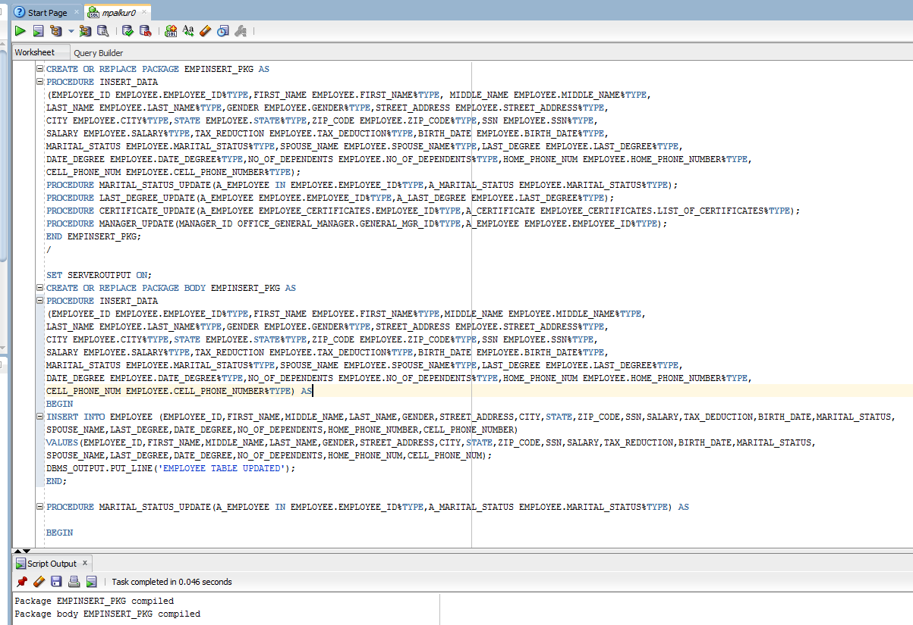

**B. INSERT_PKG**

CREATE OR REPLACE PACKAGE INSERT_PKG AS

PROCEDURE INSERT_DATA_1

(CUSTOMERID CUSTOMER.CUSTOMER_ID%TYPE,FIRST_NAME CUSTOMER.FIRST_NAME%TYPE,MIDDLE_NAME CUSTOMER.MIDDLE_INITIAL%TYPE,

LAST_NAME CUSTOMER.LAST_NAME%TYPE,STREET_ADDRESS CUSTOMER.STREET_ADDRESS%TYPE,CITY CUSTOMER.CITY%TYPE,

STATE CUSTOMER.STATE%TYPE,ZIP_CODE CUSTOMER.ZIP_CODE%TYPE,B_DATE CUSTOMER.BIRTH_DATE%TYPE,

EMAIL CUSTOMER.EMAIL%TYPE,LICENSEISSUED_STATE CUSTOMER.LICENSE_ISSUED_STATE%TYPE,

LICENSE_NO CUSTOMER.LICENSE_NUMBER%TYPE,CR_CARD_NO CUSTOMER.CREDIT_CARD_NUMBER%TYPE,

EXPIRATION_DATE CUSTOMER.EXPIRATION_DATE%TYPE,CELL_PHONENUMBER CUSTOMER.CELL_PHONE%TYPE);

PROCEDURE INSERT_NEW_CAR_OWNER(CAR_ID CAR_CLIENT_LIST.CAR_ID%TYPE,CLIENT_ID CAR_CLIENT_LIST.CLIENT_ID%TYPE,

AVAILABLE_HRS CAR_CLIENT_LIST.AVAILABLE_HRS%TYPE,START_DATE CAR_CLIENT_LIST.START_DATE%TYPE,

END_DATE CAR_CLIENT_LIST.END_DATE%TYPE);

PROCEDURE INFO_UPDATE_CUSTOMER(CUST_ID CUSTOMER.CUSTOMER_ID%TYPE,STREET CUSTOMER.STREET_ADDRESS%TYPE);

PROCEDURE INFO_UPDATE_CAROWNER(EXISTING_CAR_ID CAR_CLIENT_LIST.CAR_ID%TYPE,NEW_CLIENT_ID CAR_CLIENT_LIST.CLIENT_ID%TYPE);

PROCEDURE INSERT_ACCIDENT(CUSTOMER_ID ACCIDENT.CUSTOMER_ID%TYPE,CAR_ID ACCIDENT.CAR_ID%TYPE,DATE_TIME ACCIDENT.DATE_TIME%TYPE,

LOCATION_1 ACCIDENT.LOCATION%TYPE,DAMAGE_EXTENT ACCIDENT.DAMAGE_EXTENT%TYPE,COST_DAMAGE ACCIDENT.COST_DAMAGE%TYPE,

POLICE_REPORT ACCIDENT.POLICE_REPORT%TYPE,SUMMARY_1 ACCIDENT.SUMMARY_POLICE_REPORT%TYPE);

END INSERT_PKG;

/

SET SERVEROUTPUT ON;

CREATE OR REPLACE PACKAGE BODY INSERT_PKG AS

PROCEDURE INSERT_DATA_1

(CUSTOMERID CUSTOMER.CUSTOMER_ID%TYPE,

FIRST_NAME CUSTOMER.FIRST_NAME%TYPE,MIDDLE_NAME CUSTOMER.MIDDLE_INITIAL%TYPE,LAST_NAME CUSTOMER.LAST_NAME%TYPE,

STREET_ADDRESS CUSTOMER.STREET_ADDRESS%TYPE,CITY CUSTOMER.CITY%TYPE,STATE CUSTOMER.STATE%TYPE,ZIP_CODE CUSTOMER.ZIP_CODE%TYPE,

B_DATE CUSTOMER.BIRTH_DATE%TYPE,EMAIL CUSTOMER.EMAIL%TYPE,LICENSEISSUED_STATE CUSTOMER.LICENSE_ISSUED_STATE%TYPE,

LICENSE_NO CUSTOMER.LICENSE_NUMBER%TYPE,CR_CARD_NO CUSTOMER.CREDIT_CARD_NUMBER%TYPE,EXPIRATION_DATE CUSTOMER.EXPIRATION_DATE%TYPE,

CELL_PHONENUMBER CUSTOMER.CELL_PHONE%TYPE) AS

BEGIN

INSERT INTO CUSTOMER (CUSTOMER_ID,FIRST_NAME,MIDDLE_INITIAL,LAST_NAME,STREET_ADDRESS,CITY,STATE,ZIP_CODE,BIRTH_DATE,EMAIL,

LICENSE_ISSUED_STATE,LICENSE_NUMBER,CREDIT_CARD_NUMBER,EXPIRATION_DATE,CELL_PHONE)

VALUES(CUSTOMERID,FIRST_NAME,MIDDLE_NAME,LAST_NAME,STREET_ADDRESS,CITY,STATE,ZIP_CODE,B_DATE,EMAIL,LICENSEISSUED_STATE,LICENSE_NO,CR_CARD_NO,EXPIRATION_DATE,CELL_PHONENUMBER);

DBMS_OUTPUT.PUT_LINE('CUSTOMER TABLE UPDATED');

END;

PROCEDURE INSERT_NEW_CAR_OWNER(CAR_ID CAR_CLIENT_LIST.CAR_ID%TYPE,CLIENT_ID CAR_CLIENT_LIST.CLIENT_ID%TYPE,

AVAILABLE_HRS CAR_CLIENT_LIST.AVAILABLE_HRS%TYPE,START_DATE CAR_CLIENT_LIST.START_DATE%TYPE,

END_DATE CAR_CLIENT_LIST.END_DATE%TYPE) AS

BEGIN

INSERT INTO CAR_CLIENT_LIST(CAR_ID,CLIENT_ID,AVAILABLE_HRS,START_DATE,END_DATE)

VALUES(CAR_ID,CLIENT_ID,AVAILABLE_HRS,START_DATE,END_DATE);

DBMS_OUTPUT.PUT_LINE('NEW CAR OWNER UPDATED');

END;

PROCEDURE INFO_UPDATE_CUSTOMER(CUST_ID CUSTOMER.CUSTOMER_ID%TYPE,STREET CUSTOMER.STREET_ADDRESS%TYPE) AS

BEGIN

UPDATE CUSTOMER SET STREET_ADDRESS = STREET WHERE CUSTOMER_ID = CUST_ID;

DBMS_OUTPUT.PUT_LINE('CUSTOMER INFO UPDATED');

END;

PROCEDURE INFO_UPDATE_CAROWNER(EXISTING_CAR_ID CAR_CLIENT_LIST.CAR_ID%TYPE,NEW_CLIENT_ID CAR_CLIENT_LIST.CLIENT_ID%TYPE) AS

BEGIN

UPDATE CAR_CLIENT_LIST SET CLIENT_ID = NEW_CLIENT_ID WHERE CAR_ID = EXISTING_CAR_ID;

DBMS_OUTPUT.PUT_LINE('CARQWNER UPDATED');

END;

PROCEDURE INSERT_ACCIDENT(CUSTOMER_ID ACCIDENT.CUSTOMER_ID%TYPE,CAR_ID ACCIDENT.CAR_ID%TYPE,DATE_TIME ACCIDENT.DATE_TIME%TYPE,

LOCATION_1 ACCIDENT.LOCATION%TYPE,DAMAGE_EXTENT ACCIDENT.DAMAGE_EXTENT%TYPE,COST_DAMAGE ACCIDENT.COST_DAMAGE%TYPE,

POLICE_REPORT ACCIDENT.POLICE_REPORT%TYPE,SUMMARY_1 ACCIDENT.SUMMARY_POLICE_REPORT%TYPE) AS

BEGIN

INSERT INTO ACCIDENT(CUSTOMER_ID,CAR_ID,DATE_TIME,LOCATION,DAMAGE_EXTENT,COST_DAMAGE,POLICE_REPORT,SUMMARY_POLICE_REPORT)

VALUES (CUSTOMER_ID,CAR_ID,DATE_TIME,LOCATION_1,DAMAGE_EXTENT,COST_DAMAGE,POLICE_REPORT,SUMMARY_1);

DBMS_OUTPUT.PUT_LINE('NEW ACCIDENT UPDATED');

EXCEPTION

WHEN NO_DATA_FOUND THEN

DBMS_OUTPUT.PUT_LINE('NO DATA FOUND');

WHEN TOO_MANY_ROWS THEN

DBMS_OUTPUT.PUT_LINE('TOO MANY ROWS');

WHEN OTHERS THEN

DBMS_OUTPUT.PUT_LINE('ERROR');

END;

END INSERT_PKG;

/

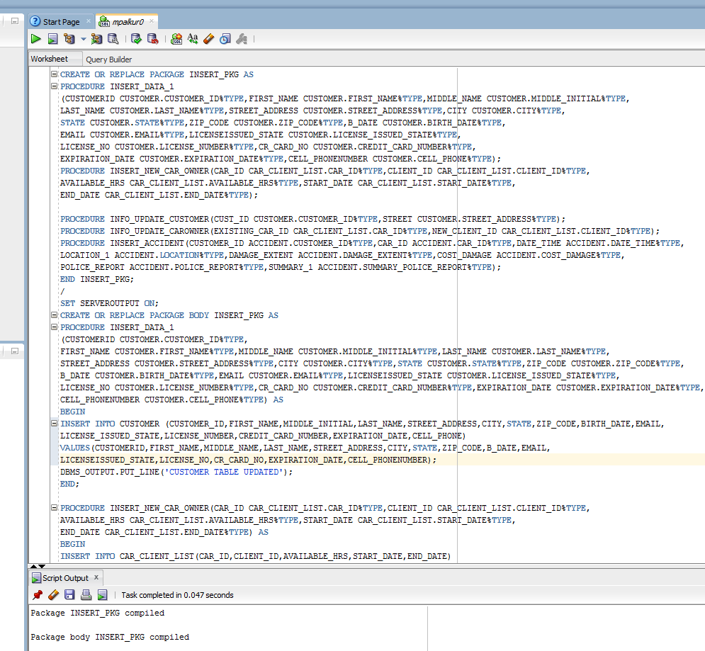

***16. Triggers: -***

G.

CREATE TABLE EMPLOYEE_HISTORY1 AS SELECT * FROM PROJECT.EMPLOYEE;

CREATE TABLE EMPLOYEE_HISTORY1 (EMPLOYEE_ID NUMBER,CITY VARCHAR2(20),STATE VARCHAR2(15),SSN NUMBER);

CREATE OR REPLACE TRIGGER EMPLOYEE_HISTORY1

AFTER DELETE ON EMPLOYEE

for each row

BEGIN

INSERT INTO EMPLOYEE_HISTORY1(EMPLOYEE_ID,FIRST_NAME,LAST_NAME,MIDDLE_NAME,STREET_ADDRESS,CITY,STATE,ZIP_CODE,SSN,SALARY,TAX_DEDUCTION,BIRTH_DATE,GENDER,MARITAL_STATUS,

SPOUSE_NAME,LAST_DEGREE,DATE_DEGREE,NO_OF_DEPENDENTS,HOME_PHONE_NUMBER,CELL_PHONE_NUMBER)

VALUES(:old.EMPLOYEE_ID,:OLD.FIRST_NAME,:OLD.LAST_NAME,:OLD.MIDDLE_NAME,:OLD.STREET_ADDRESS,:old.CITY,:old.STATE,:OLD.ZIP_CODE,:old.SSN,:OLD.SALARY,:OLD.TAX_DEDUCTION,

:OLD.BIRTH_DATE,:OLD.GENDER,:OLD.MARITAL_STATUS,:OLD.SPOUSE_NAME,:OLD.LAST_DEGREE,:OLD.DATE_DEGREE,:OLD.NO_OF_DEPENDENTS,:OLD.HOME_PHONE_NUMBER,:OLD.CELL_PHONE_NUMBER);

END;

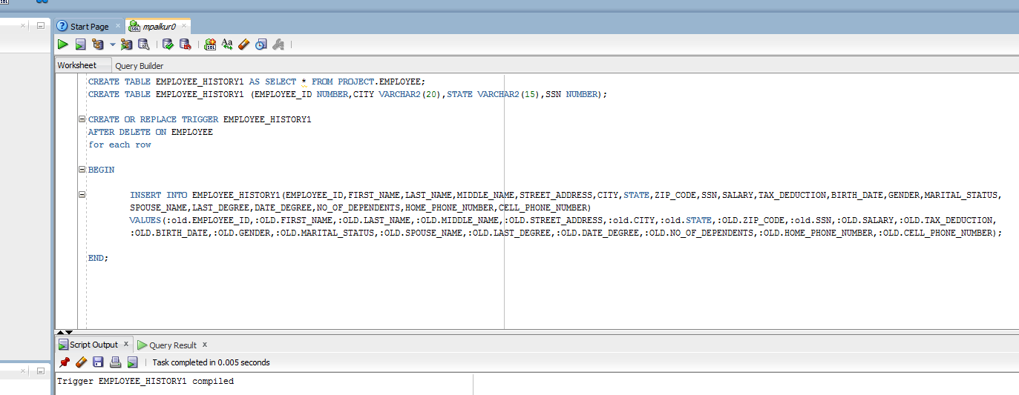

DELETE FROM EMPLOYEE WHERE EMPLOYEE_ID = 12345;

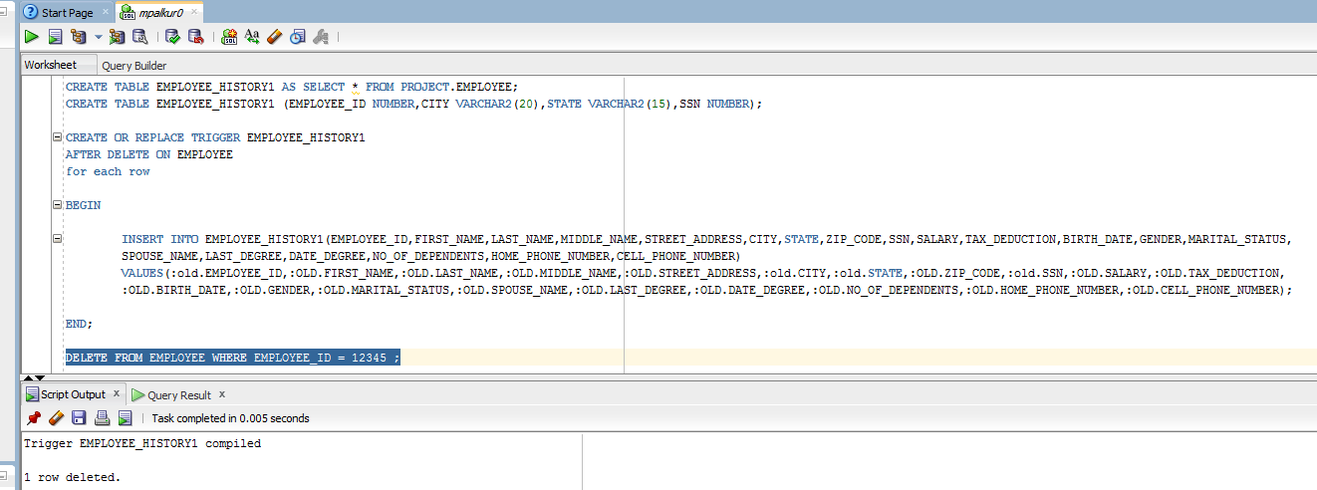

SELECT * FROM EMPLOYEE_HISTORY1;

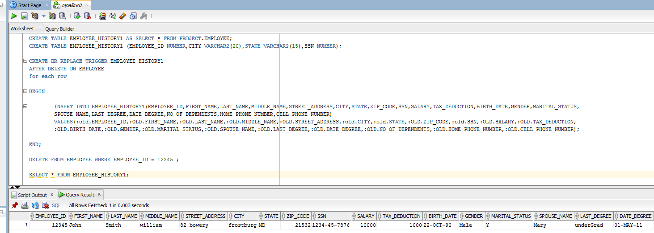

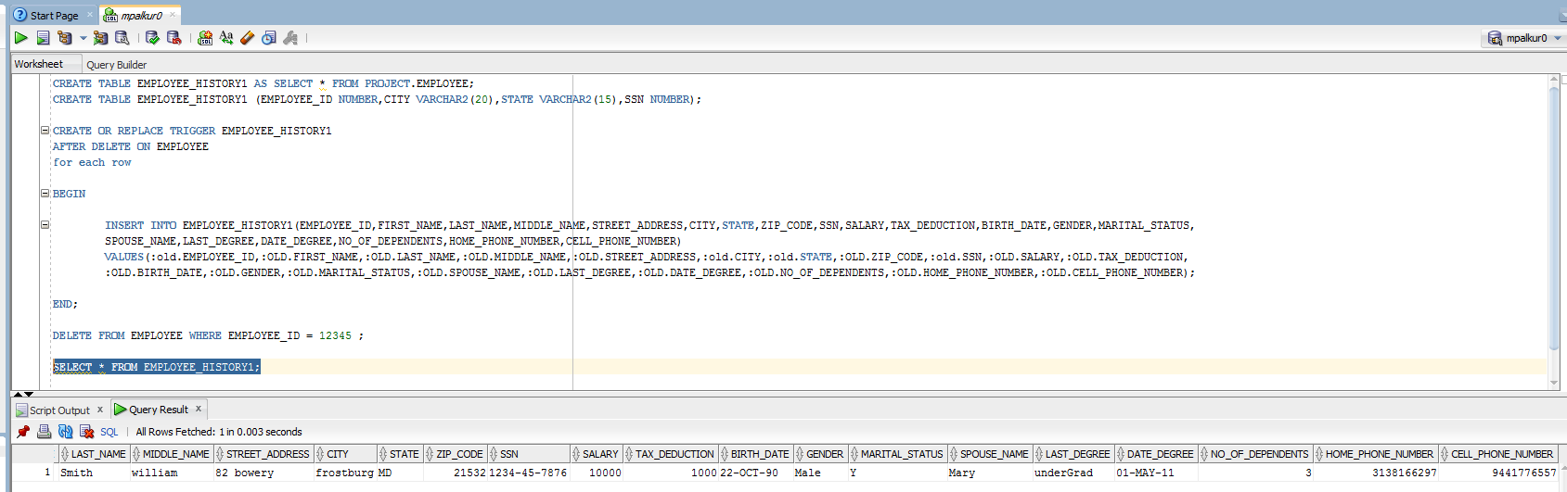

H. UPDATING: -

CREATE TABLE CUSTOMER_LOG AS SELECT * FROM PROJECT.CUSTOMER;

CREATE TABLE CUSTOMER AS SELECT * FROM PROJECT.CUSTOMER

CREATE OR REPLACE TRIGGER CUSTOMER_LOG

AFTER UPDATE ON CUSTOMER

for each row

BEGIN

INSERT INTO CUSTOMER_LOG(CUSTOMER_ID,FIRST_NAME,LAST_NAME,MIDDLE_INITIAL,BIRTH_DATE,cell_phone,

STREET_ADDRESS,CITY,STATE,ZIP_CODE,EMAIL,LICENSE_ISSUED_STATE,

LICENSE_NUMBER,CREDIT_CARD_NUMBER,EXPIRATION_DATE,SSN)

VALUES(:OLD.CUSTOMER_ID,:OLD.FIRST_NAME,:OLD.LAST_NAME,:OLD.MIDDLE_INITIAL,:OLD.BIRTH_DATE,:OLD.CELL_PHONE,

:OLD.STREET_ADDRESS,:OLD.CITY,:OLD.STATE,:OLD.ZIP_CODE,:OLD.EMAIL,:OLD.LICENSE_ISSUED_STATE,

:OLD.LICENSE_NUMBER,:OLD.CREDIT_CARD_NUMBER,:OLD.EXPIRATION_DATE,:OLD.SSN);

INSERT INTO CUSTOMER_LOG(CUSTOMER_ID,FIRST_NAME,LAST_NAME,MIDDLE_INITIAL,CELL_PHONE,BIRTH_DATE,

STREET_ADDRESS,CITY,STATE,ZIP_CODE,EMAIL,LICENSE_ISSUED_STATE,

LICENSE_NUMBER,CREDIT_CARD_NUMBER,EXPIRATION_DATE,SSN)

VALUES(:NEW.CUSTOMER_ID,:NEW.FIRST_NAME,:NEW.LAST_NAME,:NEW.MIDDLE_INITIAL,:NEW.CELL_PHONE,:NEW.BIRTH_DATE,

:NEW.STREET_ADDRESS,:NEW.CITY,:NEW.STATE,:NEW.ZIP_CODE,

:NEW.EMAIL,:NEW.LICENSE_ISSUED_STATE,:NEW.LICENSE_NUMBER,:NEW.CREDIT_CARD_NUMBER,:NEW.EXPIRATION_DATE,:NEW.SSN);

END CUSTOMER_LOG;

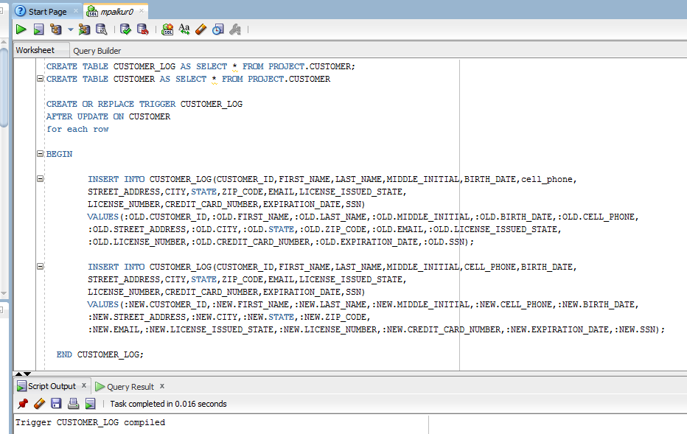

UPDATE CUSTOMER SET FIRST_NAME='JOHN' WHERE CUSTOMER_ID =1004;

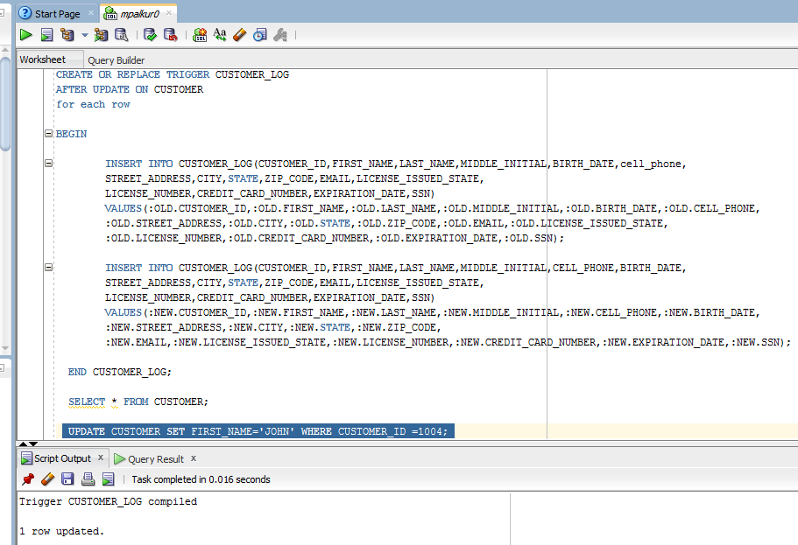

SELECT * FROM CUSTOMER;

